Partial Lesson Plan: Option A
Giving Metro/Train Directions and the Imperative

Directions: This lesson plan has been partially filled out for you. Read all the given sections and then complete the plan by filling out all blank sections (these sections are highlighted for clarity). Include materials that you create or modify, citing sources where appropriate.

Level and number of students: high beginner level/ 15 adult students
Lesson Duration: 60 minutes
Aims/Objectives: By the end of this lesson, students will be able to:
- Identify and use around 5-7 vocabulary words related to public transit via metro or train – e.g., station, kiosk, day/monthly/weekly pass, delayed, on time (option to change type of transportation and/or vocabulary words)
- Use the imperative to give directions for navigating a metro or train system – e.g., get on, get off, take XX line, stay on for XX stops, transfer at, wait until/for (option to change type of transportation and/or verbs)
- Follow and use directions given to them for navigating city public transit.

Assumptions: Students can speak, read, and write basic sentences using the present simple. Students know basic vocabulary related to transportation (i.e., drive, walk, road, street, train, car, fast, slow). In a prior lesson, students had practiced giving simple directions with a street map using the following vocabulary: go straight, turn left, go 2 blocks, on the left/right. The lesson was challenging, but manageable for most students.

Anticipated Problems & Suggested Solutions:

Materials:
- Pictures of a metro/train map (option to replace this with your own materials)
- ??
- ??
- ??

Warm-Up (5 min)
The teacher informally asks students how they got to class today and then explains how they got to class as well. Then the teacher then writes the words “Getting Around by Train” in a circle on the board (option to use another type of transportation):

Getting Around by Train

Then the teacher asks for a volunteer to explain what “getting around” means. The teacher allows for students to give various examples and then informally asks the class how they get around their city. Teacher waits for a few students to respond and then asks the following questions, “Do you like the bus? Do you like the train?” and allows students to share some informal opinions on the topic. Teacher transitions to say we are going to brainstorm vocabulary about ‘getting around by train’ and elicits vocabulary related to trains and writes what the students say into bubbles (examples will vary, see an idea below):
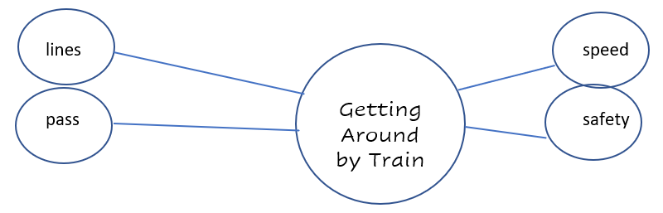

The teacher then asks students to say any words they think of related to one of the smaller circles, eliciting vocabulary and writing it down as the students say the words out loud. It could look something like this:
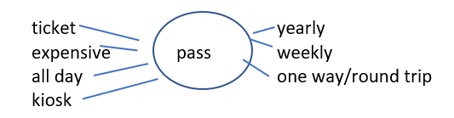

After the students get the idea, have them add to their word maps in groups of three for 2-3 minutes. Stop the groups and call on a few students to come up to the board and write what their group wrote. Go over some of the vocabulary words with the class.

Introduction (5 min)
The teacher then transitions and uses simple language to say and write the goal/objectives of the lesson in the corner of the board:
Lesson Goal: Today we will learn how to give and understand directions for riding the train.
Grammar: imperative
Vocabulary: city transportation

Presentation (time)

Practice(s)* (time)

Production (time)

Review (time)

Homework (time)

*Insert more practice sections as needed

Materials:

1. Picture of a metro/train map (see below)
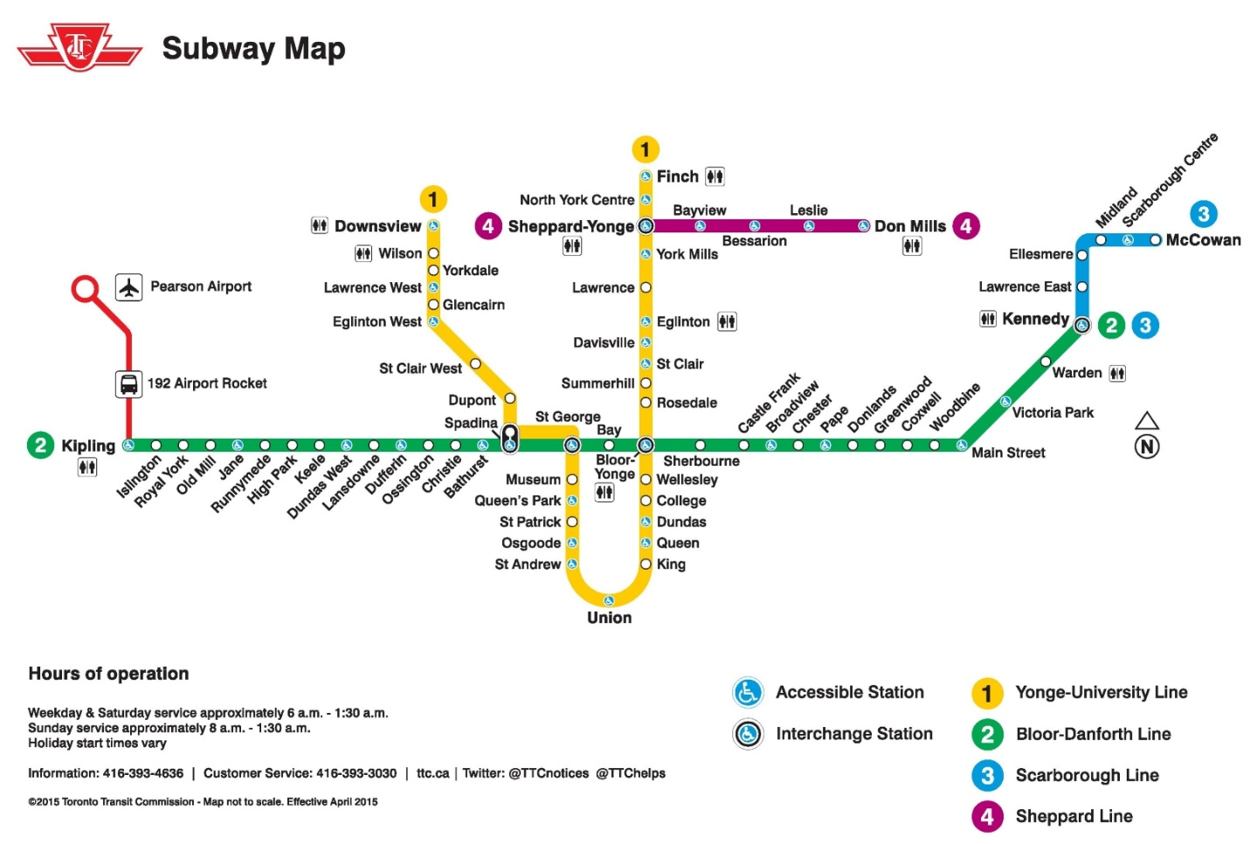
Image from https://ontheworldmap.com/canada/city/toronto/toronto-subway-map.jpg

